**“ Summer Internship as Software Developer at Northern Trust ”**

**Summer Practical Training Report**

*Submitted in Partial Fulfillment of the*

*Requirements for the Degree of*

**BACHELOR OF TECHNOLOGY**

**IN**

**ELECTRONICS AND COMMUNICATION ENGINEERING**

By

**Dhruv Dholariya**

**[ 20BEC024 ]**



**Department of Electronics and Communication Engineering,**

**Institute of Technology,**

**Nirma University,**

**Ahmedabad 382 481**

**June 2023 - August 2023**

***Internship Completion Certificate***

***Acknowledgment***

I would like to extend my heartfelt appreciation and gratitude to all the individuals and organizations who have been instrumental in the successful completion of my summer internship.First and foremost, I express my deepest gratitude to **RV Vimal (Manager)** and **Sushil Jagpat (Tech Lead)** for their unwavering support and guidance throughout the internship period. Their expert knowledge, constructive feedback, and encouragement have been invaluable in shaping the direction toward the work.

I am also thankful to the entire **Northern Trust** team for providing me with a conducive and dynamic work environment. Working alongside passionate and skilled professionals has been a tremendous learning experience, and I am grateful for the opportunities they provided me to grow and develop my skills. I am indebted to my mentors and colleagues, whose continuous support, brainstorming sessions, and insightful discussions have enriched the quality of this Internship.

Additionally, I would like to acknowledge the efforts of the Nirma University for offering me the opportunity to pursue this internship. The knowledge and skills acquired during my academic journey laid the foundation for this valuable experience.

I extend my appreciation to my family and friends for their unwavering encouragement and understanding during this internship. Their support gave me the confidence to persevere and excel in my endeavors. Your support has been instrumental in making this a successful and enriching experience**.**

***Abstract***

This report presents a comprehensive overview of my enriching summer internship experience at Northern Trust, a prominent financial custodian bank known for its extensive services in wealth management, asset management, retail banking, and finance management. During my internship, I had the privilege of working as a **React JS developer for** **Team Recon,** a dynamic team dedicated to enhancing the reconciliation system with automation capabilities, thereby streamlining human-intensive processes.

The primary focus of our project was to design and develop an advanced reconciliation system that could automate various manual tasks. Leveraging React JS, we crafted intuitive and responsive user interfaces that contributed to a seamless user experience. Additionally, our collaboration with Snowflake and Power BI allowed us to harness the potential of data analytics, enabling intelligent insights and reporting.

Furthermore, our team embraced cutting-edge technologies such as Docker and Kubernetes to build scalable and efficient deployment solutions. We also integrated Spring Boot and Liquibase to ensure robust backend functionality, facilitating data management and system reliability.

The report sheds light on the methodologies employed during the development process, including Continuous Integration/Continuous Deployment (CI/CD) pipelines, which played a crucial role in delivering iterative and reliable software.

Throughout this internship, I gained invaluable exposure to industry-standard technologies and practices, honing my technical skills and problem-solving capabilities. The challenges faced, lessons learned, and achievements made have significantly contributed to my growth as a software developer.

The experience at Northern Trust, working alongside talented professionals and engaging with diverse technologies, has undoubtedly been a transformative journey, solidifying my passion for software development in the financial domain.

Overall, this report encapsulates the significance of my summer internship, highlighting the role of React JS and a plethora of other technologies in revolutionizing the reconciliation system and automation within Northern Trust. It also serves as a testament to the dedication and commitment of Team Recon, whose collective efforts have undoubtedly made a lasting impact on the organization's operational efficiency and service delivery.

**Index**

|  |  |  |
| --- | --- | --- |
| **Chapter No** | **Title** | **Page No** |
|  | **Certificate** | **i** |
|  | **Acknowledgment** | **ii** |
|  | **Abstract** | **iii** |
|  | **Index** | **iv** |
|  | **List of Figures** | **v** |
| **1** | **Introduction** |  |
| 1.1 | Company Profile (History, Vision, Mission, Location, Products, Services, etc.) | **7** |
| 1.2 | Group Profile (Which group within the company, Management hierarchy) | **8** |
| 1.3 | Prologue | **9** |
| 1.4 | Intro to Project | **10** |
| 1.5 | Gantt Chart | **11** |
| 1.6 | Scope of Project | **11** |
| **2** | **Literature Review** |  |
| 2.1 | Previous Approaches | **12** |
| 2.2 | Tools and Technologies used | **13** |
| **3** | **Software Design** |  |
| 3.1 | Product Work Flow | **16** |
| 3.2 | Design of Recon Data Hub | **17** |
| **4** | **Conclusion and Future Conclusion** | **18** |
|  | **References** | **19** |
|  |  |  |
|  |  |  |

**List of Figures**

|  |  |  |
| --- | --- | --- |
| **Figure No** | **Title** | **Page No.** |
| **1** | Gantt Chart | **11** |
| **2** | React JS logo | **13** |
| **3** | Spring boot logo | **13** |
| **4** | Power BI logo | **13** |
| **5** | Docker logo | **14** |
| **6** | Kubernetes Logo | **14** |
| **7** | Snowflake logo | **15** |
| **8** | Liquibase logo | **15** |
| **9** | Product workflow | **16** |
| **10** | Ingestion status | **17** |
| **11** | Transformation status | **17** |
| **12** | Recon Data Hub | **17** |
|  |  |  |
|  |  |  |

**Chapter - 1**

**Introduction**

**-------------------------------------------------------------**

**1.1- Company Profile**

Northern Trust Corporation is a prominent financial services company based in Chicago, Illinois. Founded in 1889, Northern Trust has established itself as a leading provider of wealth management, asset management, banking, and asset servicing solutions to a diverse range of clients, including individuals, families, corporations, institutions, and governments. With a history spanning over a century, the company has earned a reputation for its financial stability, expertise, and commitment to client-centric services.

**Key aspects of Northern Trust include** :-

* **Wealth Management**: Northern Trust offers comprehensive wealth management services to high-net-worth individuals and families. Their offerings encompass investment management, financial planning, trust and estate services, philanthropic advisory, and private banking solutions. The company's wealth management division focuses on tailoring strategies to meet the unique needs and goals of their clients.
* **Asset Management**: The asset management arm of Northern Trust provides institutional and individual investors with a wide range of investment solutions. They manage assets across various asset classes, including equities, fixed income, alternative investments, and multi-asset portfolios. The company's asset management division caters to pension funds, sovereign wealth funds, corporations, endowments, foundations, and other institutional clients globally.
* **Asset Servicing**: Northern Trust is a major player in the asset servicing industry, providing a range of custodial, fund administration, and outsourcing services to institutional investors. They help clients manage and safeguard their assets, administer funds, and handle various administrative functions efficiently.
* **Banking Services**: As a full-service bank, Northern Trust offers a suite of banking products and services, including commercial banking, personal banking, treasury management, and foreign exchange services. Their banking solutions are tailored to meet the needs of corporations, institutions, and high-net-worth individuals.
* **Global Presence**: With offices and operations spanning across the Americas, Europe, the Middle East, Africa, and the Asia-Pacific region, Northern Trust has a significant global presence. This enables them to serve clients from different parts of the world and provide a broad spectrum of financial solutions.
* **Technology and Innovation**: Northern Trust has continuously invested in technology and innovation to enhance its services and stay at the forefront of the financial industry. They leverage advanced technologies to improve operational efficiency, data analytics, and digital solutions for their clients.
* **Corporate Social Responsibility**: The company is committed to corporate social responsibility, emphasizing ethical practices, environmental sustainability, and community engagement. They actively support various social and environmental initiatives.

Northern Trust's commitment to client satisfaction, financial expertise, and ethical practices has earned them recognition as a reliable and reputable financial institution. They continue to evolve and adapt to the changing landscape of the financial services industry while maintaining their core values and dedication to excellence.

**Location :-**

RMZ Ecospace, Sarjapur Outer Ring Road ,

Campus 1C, 2nd Floor

Bengaluru 560037

Karnataka

**1.2 Group Profile**

During my summer internship at Northern Trust, I had the opportunity to work as a **Frontend Developer for Team Recon**, a dynamic and collaborative group responsible for enhancing the reconciliation system with automation capabilities. Our team comprised five members, each contributing their unique skills and expertise to achieve project success.

**1. Sushil Jagpat (Tech Lead):**

Sushil Jagpat served as our Tech Lead, providing technical guidance and leadership to the team. With a wealth of experience in software development and expertise in different technologies, Sushil played a pivotal role in shaping the architecture and design of the reconciliation system. His mentoring and problem-solving skills were instrumental in resolving complex challenges throughout the development process.

**2. RV Vimal (Manager):**

Vimal served as our Manager, overseeing the project's progress and ensuring alignment with the organization's objectives. His strong project management abilities, coupled with a deep understanding of the financial domain, facilitated effective communication between the team and stakeholders. Vimal's guidance helped us maintain focus on project milestones and deliverables.

**3. Allen Richard (Director):**

As our Director, Allen Richard provided strategic direction and support for the entire project. His extensive experience in the financial services industry offered valuable insights into the requirements and expectations of clients. Under his leadership, we gained a broader perspective on the significance of the reconciliation system within the larger framework of Northern Trust's services.

Collectively, our group was dedicated to to revolutionize the reconciliation system at Northern Trust. The internship provided us with a platform to learn from seasoned professionals, gain exposure to cutting-edge tools, and contribute meaningfully to a critical financial process. Throughout the internship, we fostered a supportive and collaborative culture, leveraging each other's strengths to achieve our shared objectives.

The experience of working with Team Recon and the leadership provided by Sushil Jagpat, Vimal, and Allen Richard have been instrumental in shaping my skills as a software Developer and have deepened my understanding of the financial services sector. The knowledge and insights gained during this internship will undoubtedly serve as a strong foundation for my future endeavors in the software development industry.

**1.3 Prologue**

In the fast-paced world of financial services, accuracy, and efficiency are paramount. As transactions and data flow through complex networks, the need for meticulous verification and validation becomes increasingly critical. It is within this landscape that our story unfolds – the tale of the Reconciliation System Project.

The reconciliation process, though integral to the bank's operations, was laden with manual tasks and prone to human errors. These inefficiencies not only consumed valuable time and resources but also posed potential risks to the accuracy and integrity of financial data. Recognizing the pressing need to modernize and automate this vital system, Northern Trust assembled a team of adept professionals, among whom was the protagonist of our journey – the Team Recon.

Led by the seasoned Tech Lead, Sushil Jagpat, Team Recon was a close-knit group of front-end developers, driven by a shared vision of revolutionizing the reconciliation process. With Vimal as their dedicated Manager and Allen Richard as their Director, the team embarked on a transformative mission to craft an advanced Reconciliation System, one that would minimize manual intervention, maximize accuracy, and bolster operational efficiency.

**1.4 Introduction to Project**

The Recon Data Hub project was undertaken to augment the existing reconciliation system by creating a parallel system that would serve as a reliable source of historical data. The primary motivation behind this endeavor was twofold: to address critical P1 issues and to enable access to historical data for improved reporting. At the project's inception, the team recognized the necessity of a robust data hub capable of providing historical insights. The existing reconciliation system, while functional, lacked the capability to access historical data effectively. To bridge this gap, the Reconciliation Data Hub was conceived as a complementary system, designed to store and organize TLM (Transaction Lifecycle Management) data from Oracle into a cloud-based database, Snowflake.

The migration of data from the on-premise system to Snowflake offered various advantages, including enhanced scalability and cost-effectiveness. Moreover, this transformation facilitated easier data archival, enabling the team to access TLM data for extended periods, effectively solving the data retention challenge.

The focal point of the Reconciliation Data Hub was the ability to generate insightful reports from the stored data. The project aimed to empower the operating team with a comprehensive Power BI report, presenting a holistic view of the reconciliation process. This report would offer crucial insights into transaction status, providing a powerful tool for decision-making and operational efficiency. The technology stack employed for the project encompassed a Frontend Dashboard built using ReactJS, providing a user-friendly interface for monitoring ingestion and transformation statuses. The backend was powered by Spring Boot, ensuring seamless data flow and system responsiveness. The project's Ingestion Status and Transformation Status play pivotal roles in monitoring and understanding the data's journey from Oracle to Snowflake, undergoing essential transformations along the way. The Ingestion Status offers insights into the data transfer process from Oracle to Snowflake. It provides a real-time view of the data's movement, ensuring its successful arrival in the designated cloud-based database. This status serves as a vital checkpoint, assuring the team that the data ingestion process is running smoothly and efficiently. On the other hand, the Transformation Status offers a glimpse into the data's transformation journey. Starting from its raw form, the data undergoes meticulous curation, turning it into valuable, curated data. From there, it proceeds towards the final stage of becoming reporting data, which is optimized and structured for comprehensive reporting and analysis.

Throughout the development journey, the team navigated challenges with perseverance and innovation. By leveraging Snowflake's capabilities and employing the ReactJS and Spring Boot technologies, the Reconciliation Data Hub manifested as a reliable and scalable solution to the historical data access problem. With the implementation of the Reconciliation Data Hub, The Reconciliation Data Hub represented not just a technological triumph but also a significant step forward in fortifying Northern Trust's commitment to excellence and client-centric services. It stood as a testament to the power of innovation and collaboration in driving progress and elevating the standard of financial systems.

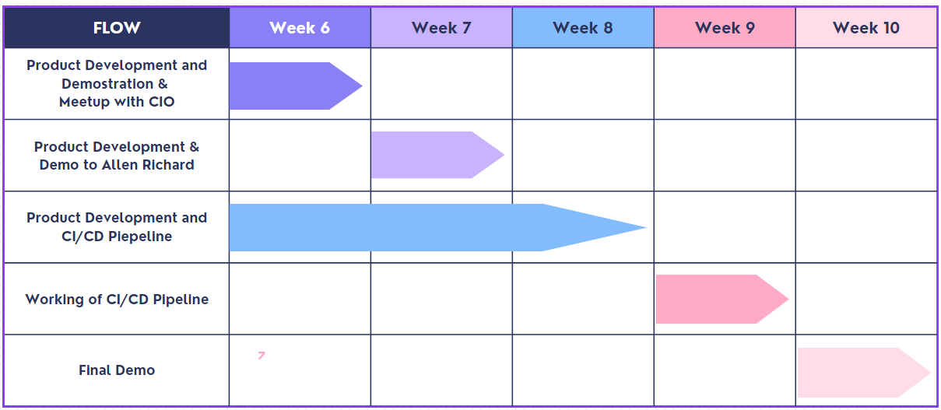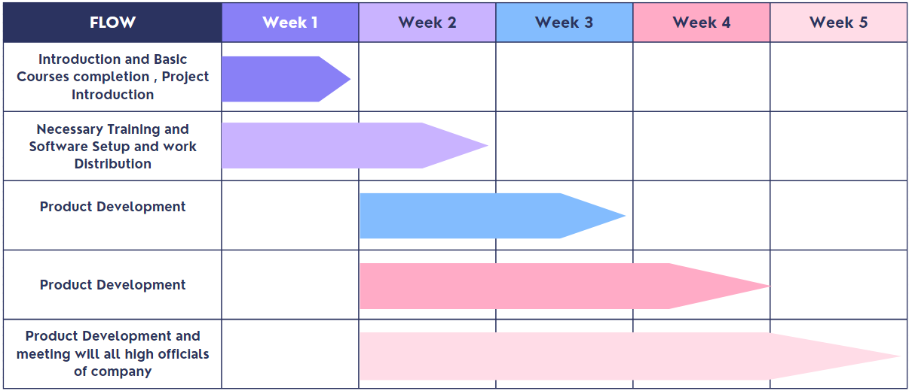**1.5 Gantt Chart**

**Figure-1**

**1.6 Scope of Project**

A reconciliation system holds significant scope in various domains, serving as a crucial tool for ensuring accuracy, consistency, and integrity of financial, operational, and data-related processes. Its primary purpose is to compare, identify, and resolve discrepancies between two or more sets of records, such as bank statements and financial transactions, inventory levels, or database entries. This system plays a pivotal role in financial institutions, businesses, and organizations, facilitating efficient audits, risk management, and compliance adherence. Moreover, it enhances operational efficiency by reducing errors, mitigating fraud risks, and streamlining data reconciliation tasks. With the increasing complexity of modern systems and the growing reliance on accurate data, the scope of reconciliation systems continues to expand, making them indispensable for maintaining a robust and transparent operational framework across various industries.

**Chapter - 2**

**Literature Review**

**-------------------------------------------------------------**

**2.1 Previous Approaches**

Historically, reconciliation processes were largely manual, involving personnel cross-checking and comparing records, invoices, statements, and other relevant documents. While this approach was prone to human errors and time-consuming, it was widely used before automation became prevalent. Some of the other approaches are :-

* **Spreadsheet-Based Reconciliation:** With the advent of spreadsheet applications like Microsoft Excel, organizations started using these tools to facilitate reconciliation tasks. Spreadsheets allowed for basic automation of calculations and comparisons, which improved efficiency compared to purely manual methods. However, the approach was still limited in handling complex data and didn't offer sophisticated automation capabilities.
* **Manual Matching Algorithms:** In some cases, organizations developed their own manual matching algorithms to reconcile data. These algorithms involved defining specific rules and conditions for matching records between datasets. While this approach offered more control over the reconciliation process, it still relied on human-defined rules and was limited in scalability.
* **Automated Reconciliation Software:** As technology advanced, dedicated software for automated reconciliation emerged. These reconciliation systems were designed to handle large volumes of data, automatically match records based on predefined rules, and identify exceptions or discrepancies. Automated reconciliation software significantly reduced the need for manual intervention, improved accuracy, and streamlined the reconciliation process.
* **Machine Learning and AI-Powered Reconciliation**: In recent years, there has been a shift towards incorporating machine learning and artificial intelligence in reconciliation systems. These advanced systems can learn from historical data, adapt to changing patterns, and make predictions to improve the accuracy and efficiency of reconciliation tasks.

It's essential to note that the reconciliation landscape has evolved significantly with the rise of automation, AI, and big data technologies, leading to more sophisticated and efficient reconciliation systems that can handle complex datasets and streamline the process for businesses and organizations.

**2.2 Details of Tools and Technologies used**

* **ReactJS**

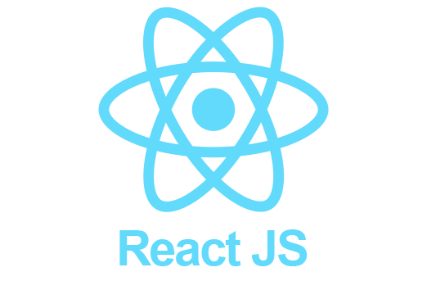React.js is an open-source JavaScript library primarily used for building user interfaces (UI) and front-end web applications. Developed and maintained by Facebook, React allows developers to create interactive, dynamic, and efficient UI components that can seamlessly update in response to changes in data without requiring a full page reload.React.js has gained immense popularity due to its performance, scalability, and the developer-friendly approach it offers. It is widely used by web developers to create modern, interactive, and responsive user interfaces for a wide range of applications, from single-page web applications to complex enterprise-level systems.

**Figure-2**

* **Spring boot**

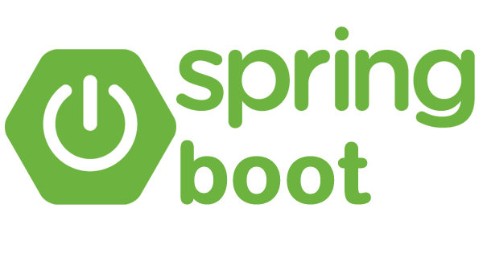Spring Boot is an open-source Java-based framework developed by Pivotal Software (now VMware) that simplifies the process of building and deploying standalone, production-ready Spring-based applications. It is a part of the larger Spring ecosystem, which is widely used in enterprise Java development.Spring Boot has gained significant popularity in the Java community due to its ease of use, robustness, and ability to simplify the development process. It is widely used to build a wide range of applications, including web applications, RESTful APIs, microservices, and more, making it a versatile and valuable framework in modern Java development.

**Figure-3**

* **Power BI**

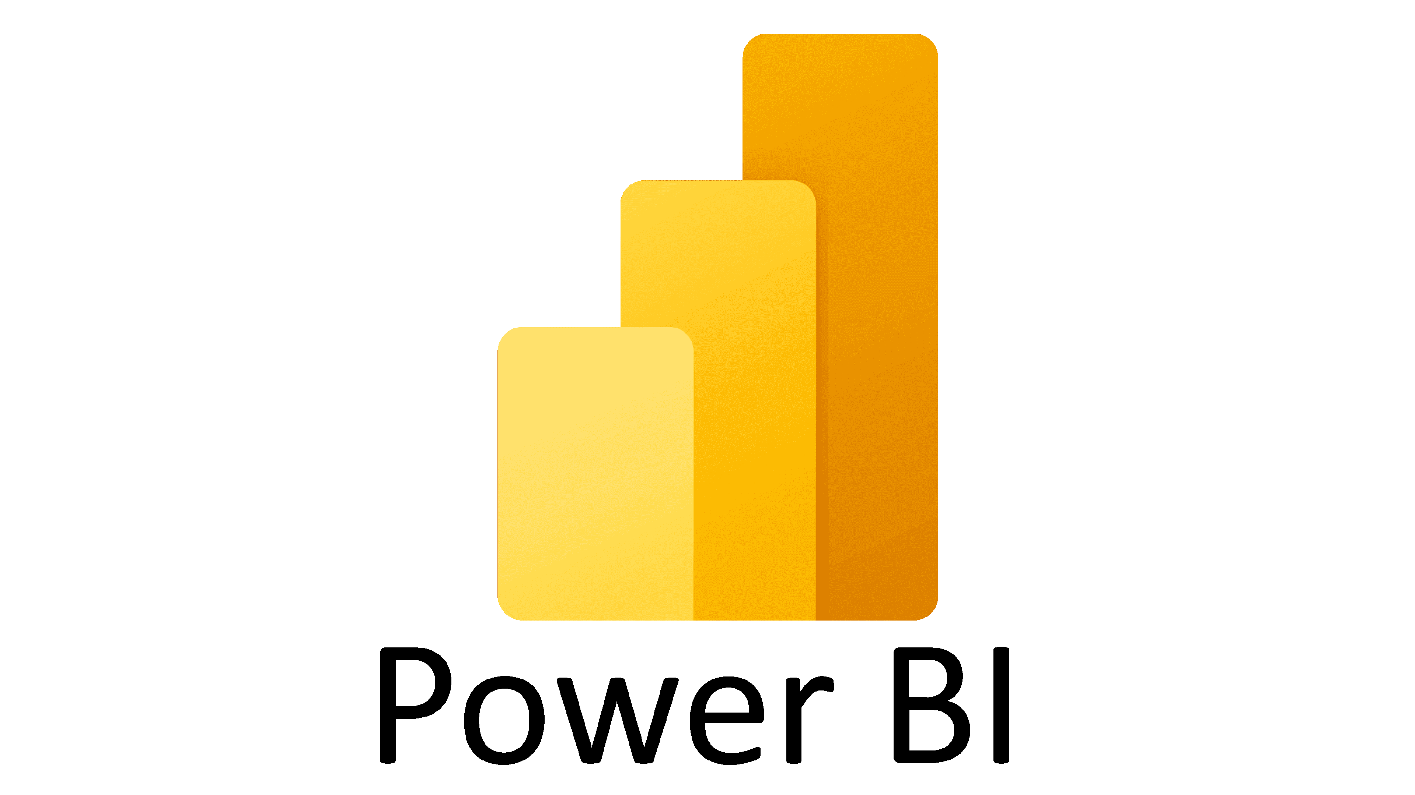Power BI is a business analytics service provided by Microsoft that allows users to visualize and analyze data quickly and effectively. It enables organizations to make data-driven decisions by transforming raw data into interactive and visually appealing reports, dashboards, and data visualizations. Power BI is widely used across various industries and business domains to gain insights from data, identify trends, and monitor key performance indicators (KPIs).

**Figure-4**

* **Docker**

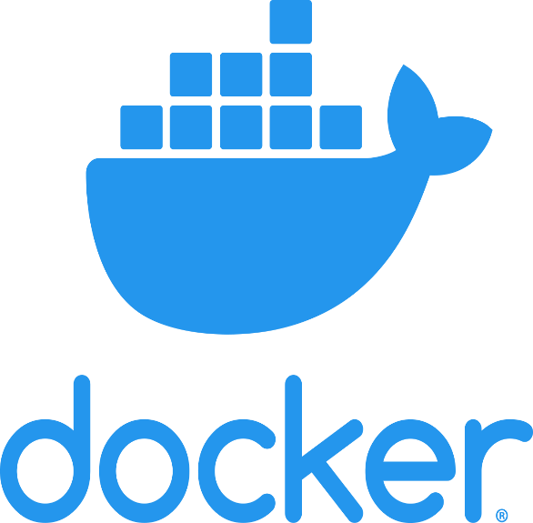Docker is an open-source platform that allows developers to automate the deployment, scaling, and management of applications inside lightweight, portable containers. Containers are a form of virtualization that isolates applications and their dependencies, enabling them to run consistently across different environments, such as development, testing, and production, without changes or conflicts.Docker has revolutionized software development and deployment by providing a standardized and efficient approach to building, shipping, and running applications. It has become an essential tool for modern software development, enabling faster development cycles, easier collaboration, and seamless deployment of applications in diverse environments.

**Figure-5**

* **Kubernetes**

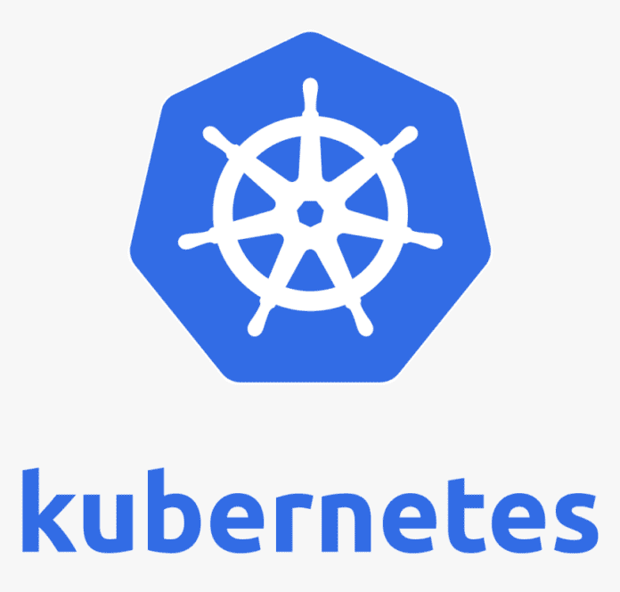Kubernetes (often abbreviated as K8s) is an open-source container orchestration platform designed to automate the deployment, scaling, and management of containerized applications. Originally developed by Google and later donated to the Cloud Native Computing Foundation (CNCF), Kubernetes has become the de facto standard for managing containerized workloads in production environments.Kubernetes provides a powerful and flexible platform for managing containerized workloads, making it particularly well-suited for deploying and scaling microservices, cloud-native applications, and complex,

**Figure-6**

distributed systems. It offers numerous benefits, including high availability, fault tolerance, automatic scaling, and declarative management, which have made it a popular choice among developers and IT operations teams for modern application deployments. Kubernetes is an essential tool in the cloud-native ecosystem, supporting the development and deployment of containerized applications across diverse cloud and on-premises environments.

* **Snowflake**

****Snowflake is a cloud-based data warehousing platform that provides a fully-managed, scalable, and secure solution for storing and analyzing large volumes of data. It is designed to address the challenges of traditional on-premises data warehousing, offering a cloud-native approach that enables organizations to store, process, and analyze data efficiently.Snowflake's architecture and features make it an attractive choice for organizations looking to modernize their data infrastructure and analytics capabilities. It simplifies data management, reduces operational overhead, and allows businesses to focus on data-driven insights and decision-making. As a result, Snowflake has gained significant popularity and has become a leading cloud data warehousing solution in the industry.

**Figure-7**

* **Liquibase**

Liquibase is an open-source database schema version control and migration tool. It provides developers and database administrators with a way to manage and track changes to database schemas over time, ensuring consistency and integrity across different environments and software releases.Using Liquibase, developers can ensure that database schemas evolve safely and consistently over time as the application evolves. By managing database changes in a version-controlled manner, Liquibase promotes collaboration among team members, reduces the risk of schema conflicts, and improves the reliability and maintainability of the database schema. It is particularly valuable in agile development environments where frequent changes to the database structure are common.

**Figure-8**

**Chapter - 3**

**Software Design**

**-------------------------------------------------------------**

* **Product Work Flow**

**Data Sources**

(Account , Balances, Transactions, Assets and Pricings )

**Data Validation and Quality Framework**

**TLM**

**TLM**

**TLM**

**Historical & Incremental Data load**

**Recon Data Hub**

* **Exceptions Data Product**
* **Power BI Reporting**
* **Improved Auto matching**

**Figure-9**

* **Design of Recon Data Hub**

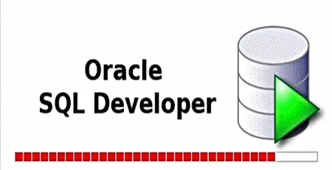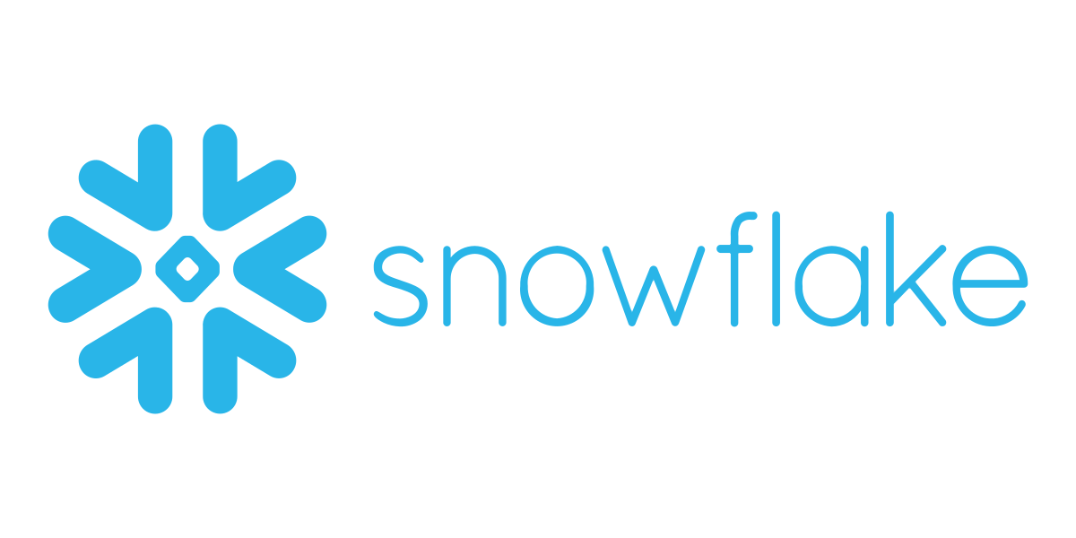

Ingestion

Column type database

Row type database

**Figure-10**

**Transformation Inside snowflake**

Reporting status

Migration status

**Figure-11**

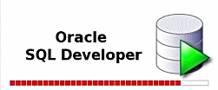

Transformation status

Ingestion status

Reporting Data from snowflake used for making power BI Report

Dashboard

**Figure-12**

**Chapter - 4**

**Conclusion and Future Scope**

**-------------------------------------------------------------**

In conclusion, my summer internship with Team Recon Data Hub of Northern Trust was an exceptional experience that provided me with invaluable insights and practical skills in the field of software development. As a React.js developer, I played a significant role in a remarkable project focused on TLM data ingestion and transformation. Our primary objective was to visualize the data's progression from raw to curated and reporting data using a dynamic dashboard.

The transformation of reporting data emerged as a critical aspect of our work, enabling us to generate insightful Power BI reports. By integrating Docker into the process, we efficiently scheduled automatic report delivery, enhancing accessibility and productivity for end-users.

Beyond our core responsibilities, our team delved into the exciting realm of machine learning, aiming to automate and optimize the data processing pipeline. This journey into AI integration opened up new possibilities for creating a more intelligent and efficient system.

Throughout the internship, I acquired hands-on expertise in React.js, cloud-based databases, and the fascinating world of machine learning. My skills in version control using Liquibase were honed, setting the groundwork for a robust CI/CD pipeline.

The internship allowed me to explore both front-end and back-end development, leveraging React.js and Spring Boot to create dynamic and user-friendly interfaces. Working with tools like PowerBI, Material UI, and AG Grid expanded my capabilities in data visualization and management.

The exposure to Agile development practices fostered a collaborative and iterative work environment, enhancing our team's productivity and communication. Additionally, the Professional Partners course offered valuable insights into corporate dynamics, enhancing my understanding of effective teamwork within the corporate setting.

Overall, this internship has been an incredible learning journey, equipping me with proficiency in cutting-edge technologies, a deep appreciation for Agile methodologies, and a comprehensive understanding of corporate operations. I am immensely grateful for the knowledge I gained and the support of the wonderful team that made this journey truly unforgettable. The experience has undoubtedly shaped me both professionally and personally, and I look forward to applying these skills and insights in my future endeavors with confidence and enthusiasm.

**References**

[1] Anaeto. E,(2013),Tracking the excess bank charges.

[2] Jegede C.A.(2014) Effects of Automated Teller Machine on the Performance of Nigerian

Banks.

[3] American Journal of Applied Mathematics and Statistics, 2(1), 40-4

[4] Kent J, & Irfanyllah (2008),How to Prepare a Bank Reconciliation Statement in a Company.

[5] Department of Finance District Treasury Procedures and Controls (2006), Bank Reconciliation Procedures